Scenario 1 — Search Functionality
Weak: "Test the search feature."
What's missing:
No product type (e-commerce, hospital),
no filter/sort behavior, no empty/invalid input scenarios, no performance angle.
Rewritten ICEPOT Prompt
Act as senior Engineer
Product is E commerce
List out testcase in both Functional and not functional
For functional testcover - Invalid input entry, Empty entry, Special character entry, misspelled words, Sort by price, Sort by old/ new, trendy
Need output in form of table with column as test case ID, Test scenarios, Test steps, expected results
Content need to be in Formal
Weak Prompt Output
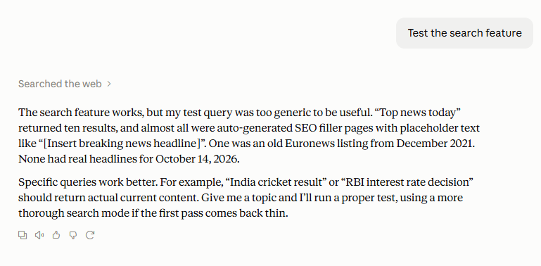
ICEPOT Prompt Output

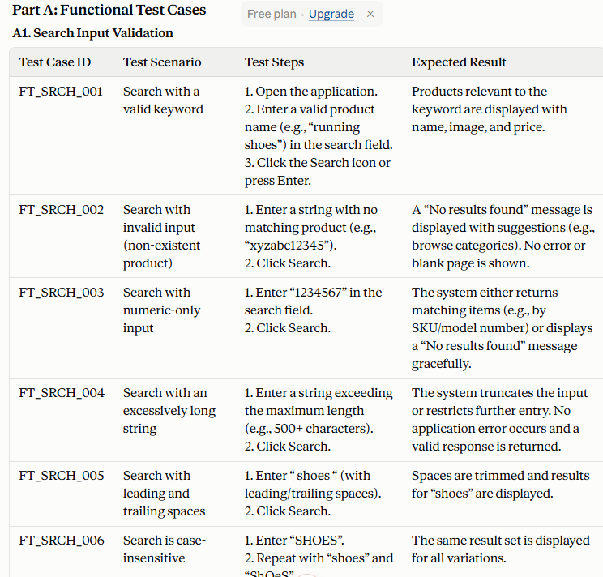
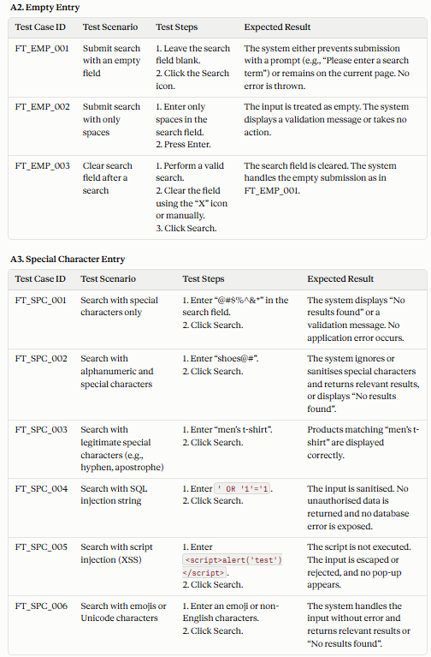
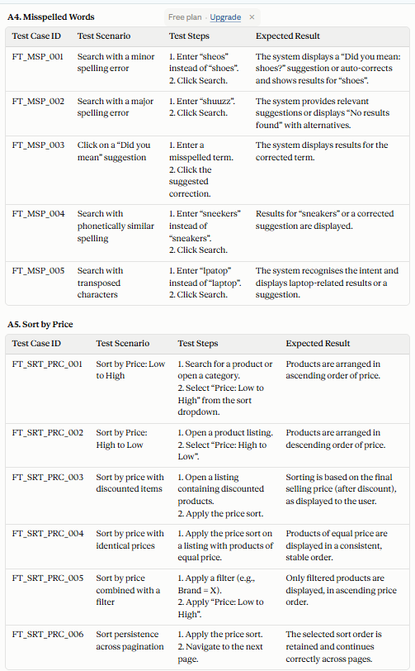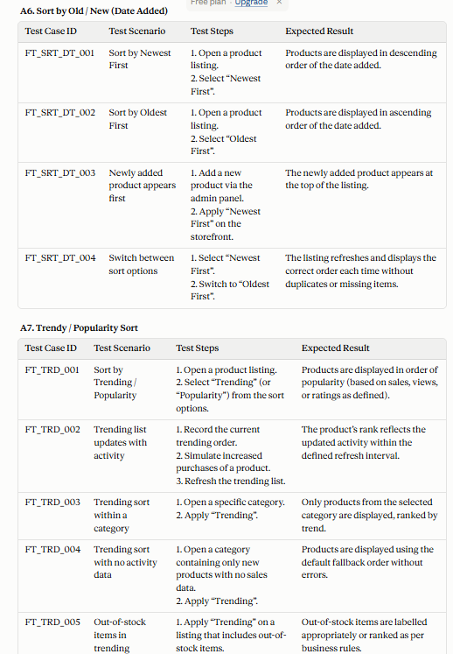
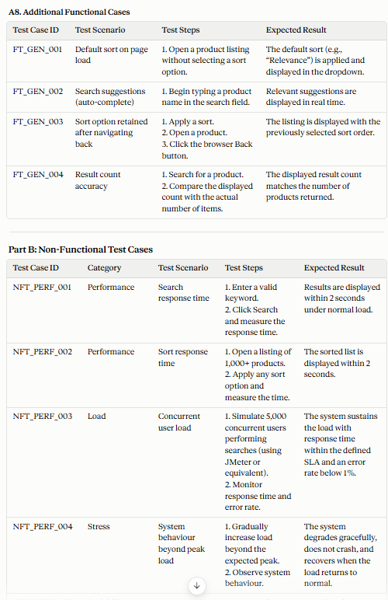
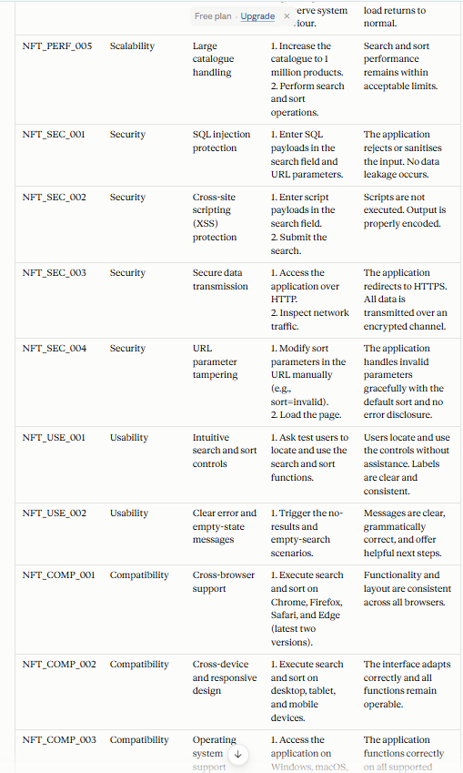
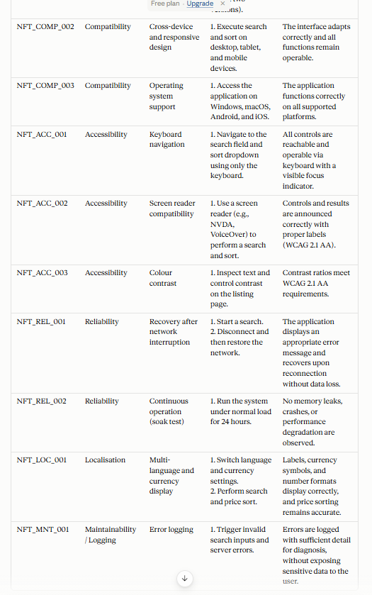
Observation
Got Test cases that targeted E commerce rather than generic
More test case coverage – Positive negative Edge cases
Immediately and download or copy/paste.
-------------------------------------------------------------------------------------------------------------Scenario 2 — File Upload
Weak: "Generate test cases for file upload."
What's missing: No file types, no size limits,
no success/failure criteria, no security angle (malicious file upload).
Rewritten ICEPOT Prompt
Act as senior Engineer
Can support – file format as docs, Excel alone with size range between 10 to 15 kb
List out testcase in both Functional and not functional for — File Upload
For functional testcover - Invalid Format, Empty entry, Size range not fit , Success message, proper error message
Need output in form of table with column as test case ID, Test scenarios, Test steps, expected results
Content need to be in Formal
Weak Prompt Output
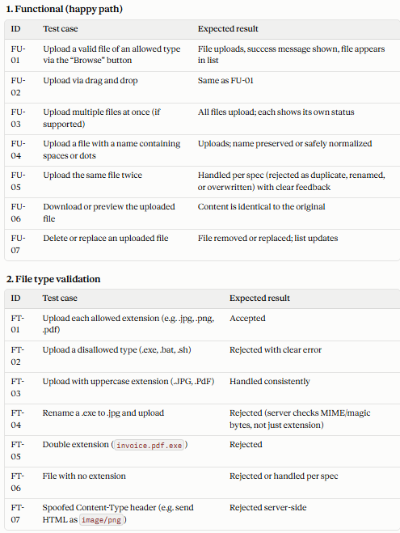
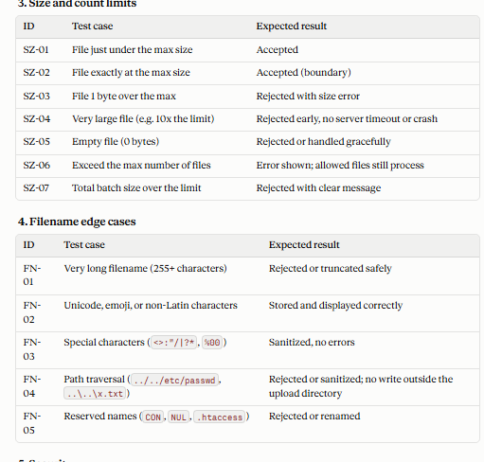
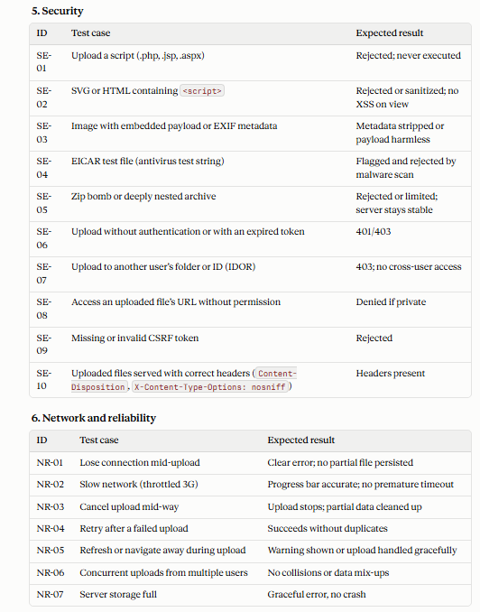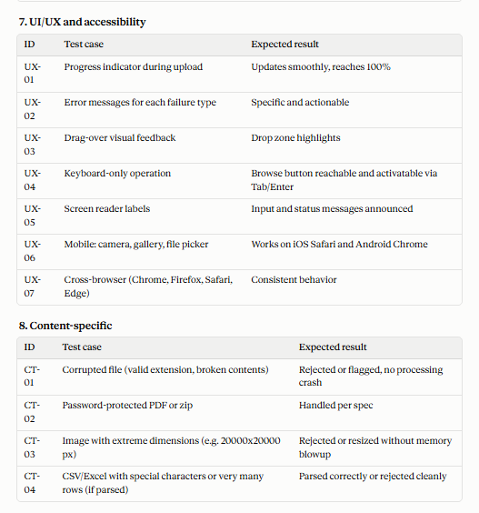
ICEPOT Prompt Output
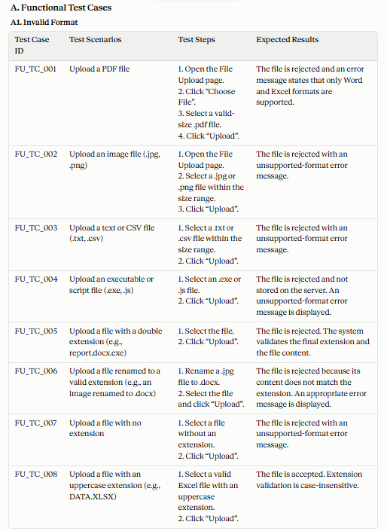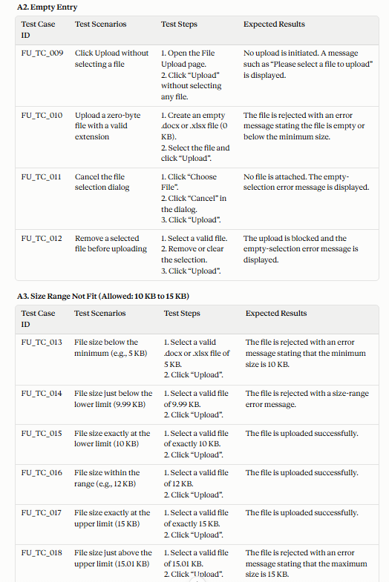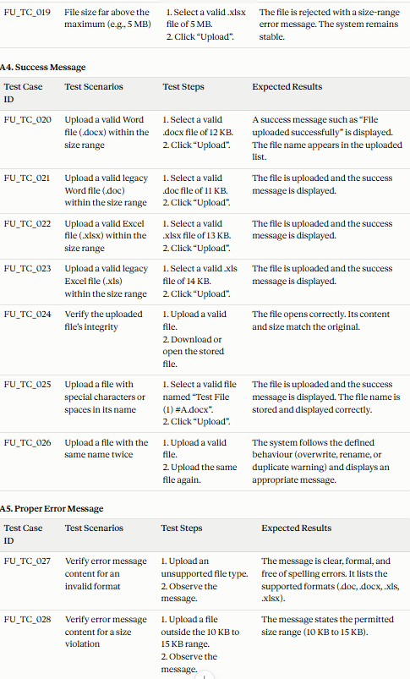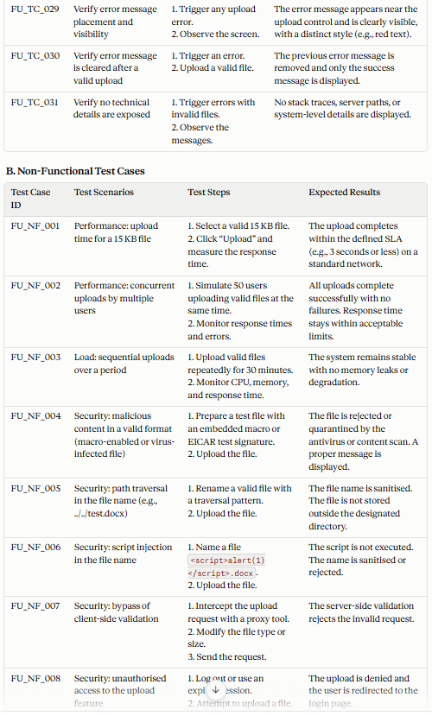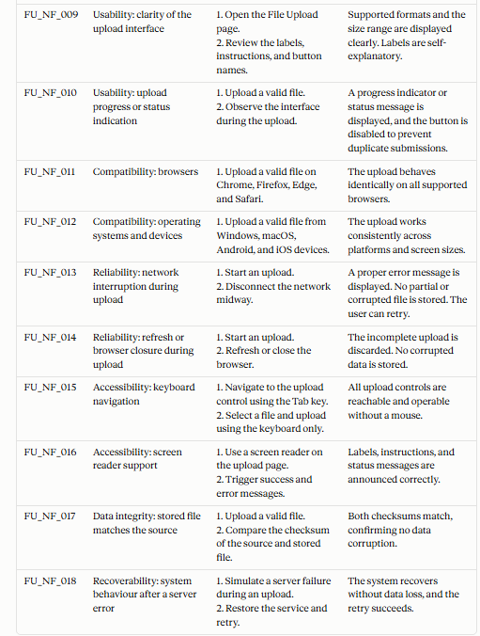
Observation
Got Test cases that targeted File upload rather than generic
More test case coverage – Positive negative Edge cases
Immediately and download or copy/paste.

Scenario 3— Shopping Cart
Weak: "Test the cart functionality."
What's missing: No add/remove/update actions,
no price calculation validation, no coupon/discount scenarios, no out-of-stock handling.
Rewritten ICEPOT Prompt
Act as senior Engineer
Product is E commerce
List out testcase in both Functional and not functional for — Shopping Cart –
For functional testcover – Clickable, Count, Sign in button for non logged in user, signup button, Proper message, amount , quantity, out of stock, coupons, calculation – all handling
, Need output in form of table with column as test case ID, Test scenarios, Test steps, expected results
Content need to be in Formal

Weak Prompt Output
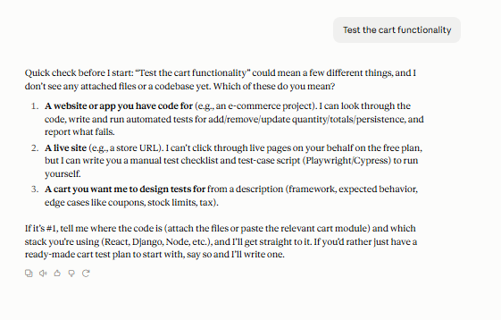
ICEPOT Prompt Output
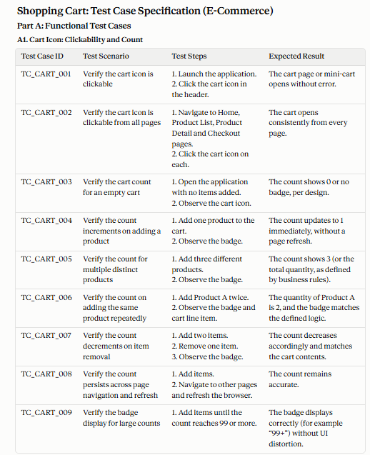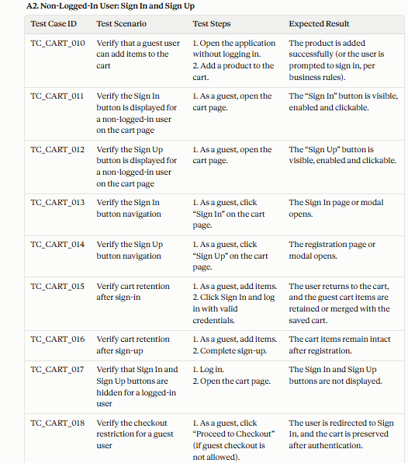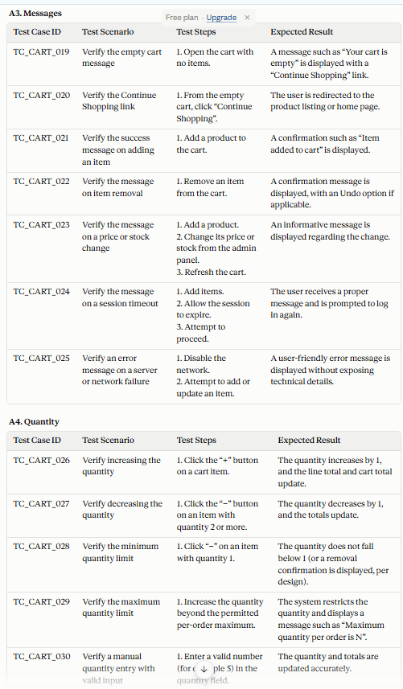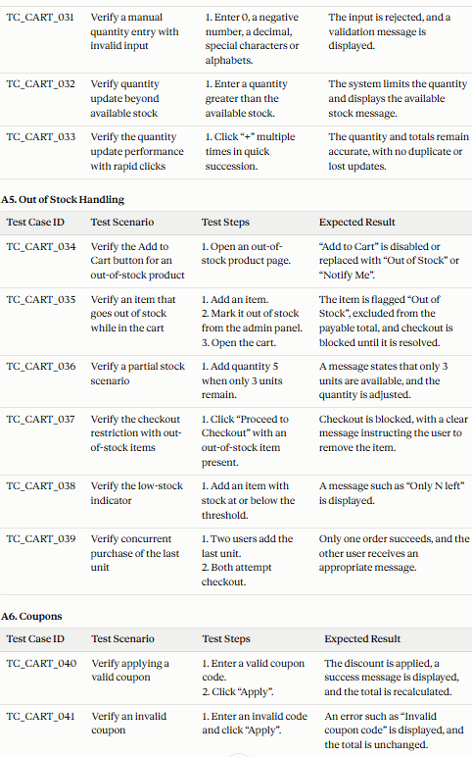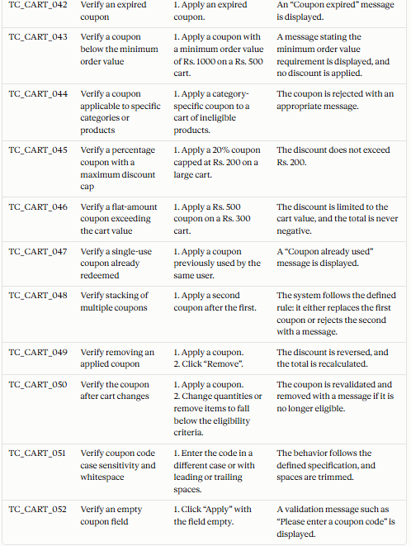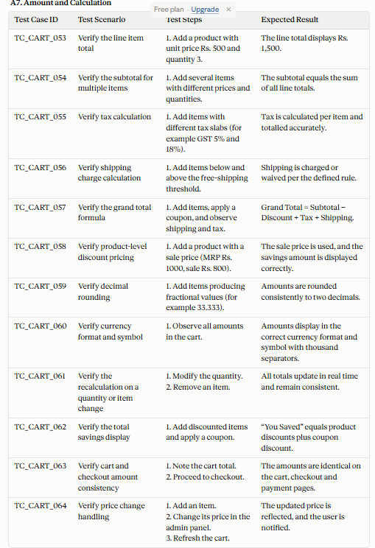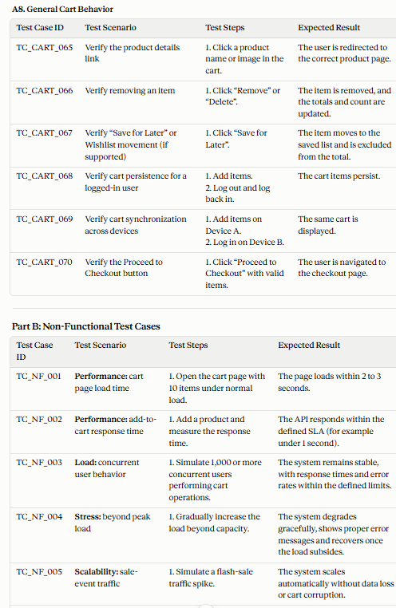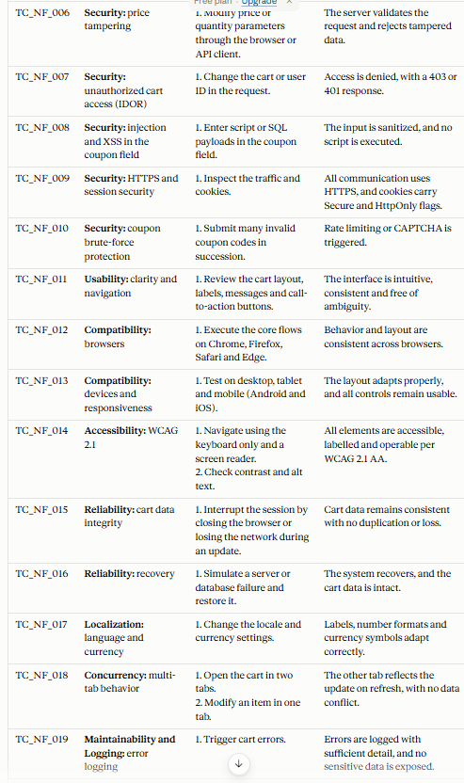
Observation
Got Test cases that targeted Shopping cart
More test case coverage – Positive negative Edge cases
Immediately and download or copy/paste.

